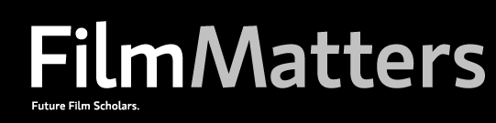
Open Call for Undergraduate Papers

Film Matters, published by Intellect, is seeking papers written by undergraduate film scholars for issue 8.1 (2017). For more information about Film Matters, please visit:

- http://www.intellectbooks.co.uk/journals/view-Journal,id=187/
- http://filmmattersmagazine.com/

Calls for papers are open to any undergraduate student, currently enrolled at an institution of higher learning worldwide and working towards a Bachelor’s degree in any field. Recent graduates are also eligible, providing they submit to a call, the deadline for which occurs within six months from their graduation date (or up to a year, providing that the recent graduate is not enrolled in graduate school). Any original piece of written scholarship, involving film criticism, history, or theory will be considered for publication. By submitting a paper for a call, authors are certifying that: (1) they are undergraduate students, currently enrolled at an institution of higher learning and working towards a Bachelor’s degree (or they are recent graduates of twelve months or less from the date of the call deadline, providing they are not enrolled in graduate school); and (2) their submitted essays are original pieces of written scholarship, authored solely by them, and have not been published in any form, in any publication, heretofore.

Submissions should be written in English and range from 2,500 to 4,000 words in length, with 3,000 words being the ideal target. They should be scholarly in nature, with references to research formatted according to MLA guidelines (7th edition). Essays incorporating images or that could easily incorporate images are of particular interest. Furthermore, they should make a well-supported argument and not simply report. Please limit your submissions to one per author, per call.

After a prescreening, submissions will undergo a blind peer review process, typical of scholarly journals. Referee comments will be returned to those authors who progress beyond the prescreening; unfortunately, due to the high number of submissions, the editorial board is unable to provide comments to those papers that do not make it past this point. Authors of accepted papers will be expected to work closely with the FM editorial board to revise their pieces prior to publication. Please include a cover sheet, which includes the author’s name, title of essay, institutional affiliation, and contact information; all other identifying information should be removed from the body of the text, in order to aid the blind peer review process.

Please email submissions as Microsoft Word email attachments to: futurefilmscholars@gmail.com.

Submissions should be received by February 1, 2016 for consideration in issue 8.1.

All questions should be referred to Liza Palmer (futurefilmscholars@gmail.com).

